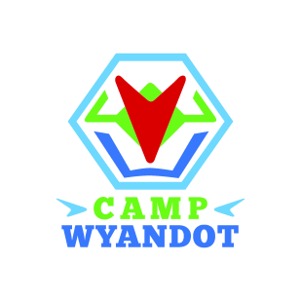
Camp Wyandot Day Camp
Camp Director
Position Description
You must be available June 5, 2016 through August 15, 2016 for staff training, camp duration, and wrap-up. You must also have limited availability in April and May for meetings, planning, and preparation.
Resumes and Cover Letters must be received by February 29, 2016; no phone calls please.
To apply, please send your resume and cover letter to Connie Coutellier, Acting Executive Director – connie@campwyandot.org
Position: Camp Wyandot Day Camp Director
Position Location: Columbus, Ohio
Camp Wyandot, Inc. Location: 1890 Northwest Blvd, Suite 130, Columbus, OH 43212
Minimum Qualifications: High School Diploma, 21 years of age or older at the start of camp season, 2 years Program Administration, Customer Service experience, ability to lift 25 pounds, 4-5 years experience working with children.
Preferred Qualifications: 4 year College Degree
Essential Position Functions: Must have minimum of 2 years supervisory experience, must have knowledge of best practices in field of education and/or day camp, must have good written and verbal communication skills, and must be able to manage multiple projects.
KEY AREAS OF RESPONSIBILITY
Program Administration
- Respond to requests for program information in timely manner (phone and e-mail);
- Maintain individual camper and staff files and consolidate at end of each camp session;
- Work closely with Program Coordinator to reconcile weekly payment of program participants;
- Facilitate Communications between families and Camp Wyandot, Inc.
Statistical/Financial
- Receipt in money for Camp Wyandot, maintain cash/checks in a secure place and deliver to Camp Wyandot office on weekly basis;
- Reconcile cash/checks with Program Coordinator upon delivery;
- Complete weekly status reports for program attendance;
- Compile program report at end of season;
- Prepare requested reports for Program Coordinator
Program Coordination
- Operate Program in full compliance with Camp Wyandot, Inc. standards;
- Ensure on-site filing/storage of Parent Consent Forms and Health Forms;
- Utilize Camp Wyandot curriculum and augment with other age appropriate best practices when appropriate.
Human Resources
- Supervise, monitor and evaluate staff in a proactive manner, evaluating performance on an ongoing basis;
- Provide Staff Manual for all staff/volunteers and update as needed;
- Conduct/coordinate staff/volunteer orientations and training;
- Must be able to mediate issues between campers, parents, and staff.
General Responsibilities
- Identify opportunities for donations and/or in-kind gifts;
- Coordinate and/or assist with special projects as assigned;
- Keep site location area neat and clean, including sweeping and trash removal according to campsite guidelines;
- Assist with other duties as assigned;
- Meet with Executive Director and Program Coordinator on a periodic basis to discuss issues, make recommendations, and provide program status information.

